Z-3392 Software protocol

Specification v1.00

Date: Apr 18th, 2018
Strictely confidential document



I. Summary

I. Summary 2

II. Introduction 3
Hardware configuration 3
III. Protocol of communication (UART/Virtual COM) 4
Normal mode 4
Instant Command 4
General Command 5

IV. List of Instant Command 7
V. List of General Command 8

II. Introduction

This document aims to describe the protocol of communication between Z-3392 and remote application:

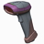
Application

Z-3392 Remote Application

Hardware configuration
This communication between the Z-3392 MPU and the Remote Application is based its hardware link:

UART Setting

. RS232 TTL (Rx & Tx)
. Baud Rate: 9600 (changeable)
. Data Bits: 8 (changeable)
. Parity: None (changeable)
. Hardware flow control : disable (changeable)
. Stop bits : 1 (changeable)

III. Protocol of communication (UART/Virtual Com)

Between the Z-3392 MPU and the remote application

1. Normal mode:
Format of packet
To send a data (command or configuration data…) to the Z-3392, the remote application has to encapsulate it:

There are three types to Format of packet

Type I: Instant Command

Command ID
1 byte

The length of commands is only one byte to control Z-3392 at once.

0x0E Hex | enable (resumes from disable) | Shift Out or <Ctrl-N>
0x0F Hex | disable | Shift In or <Ctrl-O>

Example:
Sending 0x0F to Z-3392 will disable the scanner.

When receive this type of command, Z-3392 will execute it immediately and will NOT send an ACK(06H) to remote application.

Type II: General Commands

Command ID (0xAA) | Command Strings
1 byte | N bytes

Examples:
Sending <0xAA> <~ZBB00070001.> to Z-3392 will enable Code 39.
Sending <0xAA> <~ZBB00070100.> to Z-3392 will disable Code 39.

- When receive a General Command, Z-3392 will execute it and send an ACK(0x06) to remote application.

Type III: Software Trigger Command

Trigger command format
Level Trigger Scan Command 1：<ESC> A0 <CR>
(Scan off when trigger off command by received)
Level Trigger Scan Command 2：<ESC> A2 <CR>
(Scan off when data scanned )

Edge Trigger Scan Command 1：<ESC> A0. mm <CR>
(Scan off when data scanned or “mm” timeout)
mm=1 ~ 60 (Sec)
Edge Trigger Scan Command 2：<ESC> A2. mm <CR>
(Scan off when “mm” timeout)
mm=1 ~ 60 (Sec)

Trigger off Command：<ESC> A1 <CR>

- NOTE：
1. The edge trigger command that do not control by the trigger off command.
2. Scanner will start the next scan if it receives an edge trigger command and the device remain “mm” time.

Examples:
Sending <ESC> “A0” <CR> (0x1b 0x41 0x30 0x0d) to Z-5111 will active the Z-3392 to scan .
Sending <ESC> “A1” <CR> (0x1b 0x41 0x31 0x0d) to Z-5111 will off scan.

IV. List of General Command
System Function setting
Setting Barcode | Description | Command strings
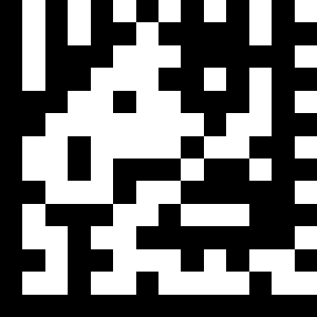 | Reset (return to factory default) | ~ZBX000000.
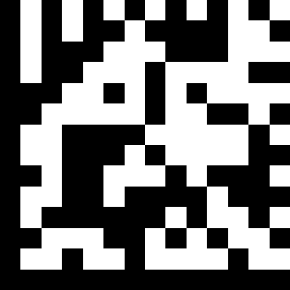 | Display firmware version | ~ZBX000100!
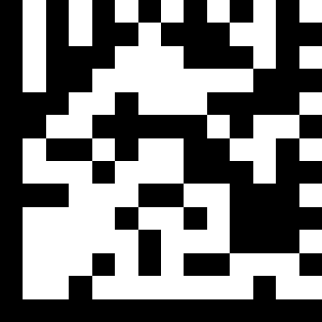 | Medium beeper tone | ~ZBX001201.
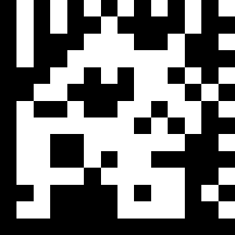 | Low beeper tone | ~ZBX001202.
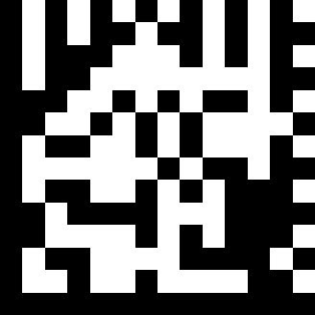 | High beeper tone | ~ZBX001203.
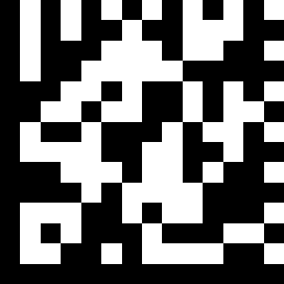 | Speaker disable | ~ZBX001205.
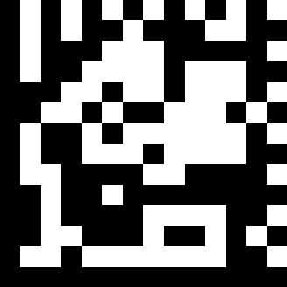 | Long sound duration (100msec) | ~ZBX001210.
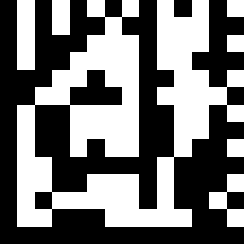 | Medium sound duration(50msec) | ~ZBX001211.
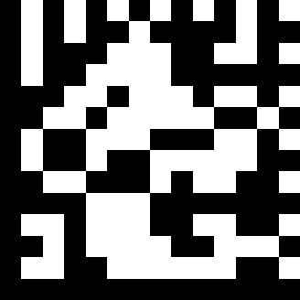 | Short sound duration(20msec) | ~ZBX001212.
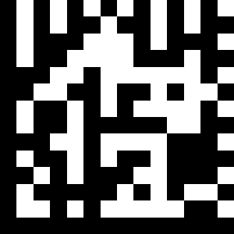 | Very short sound duration(5msec) | ~ZBX001213.
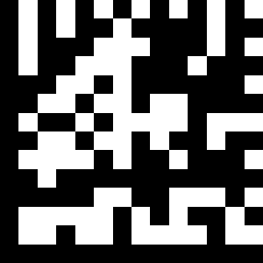 | Very Long sound duration (200msec) | ~ZBX001214.
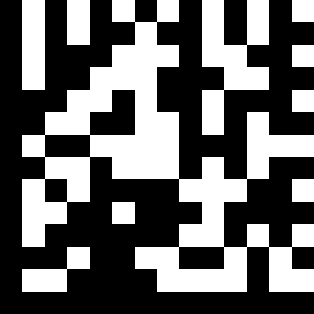 | Ultra long sound duration (500msec) | ~ZBX001215.
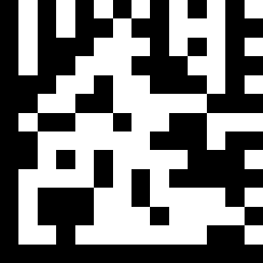 | LOUD VOLUME (50/50 duty) | ~ZBX001220.
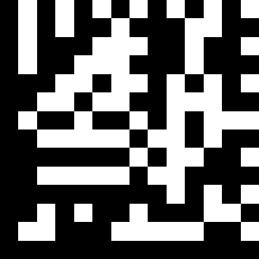 | MEDIUM VOLUME (30/70 duty) | ~ZBX001221.
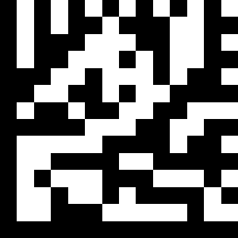 | Slight volume (20/80 duty) | ~ZBX001222.
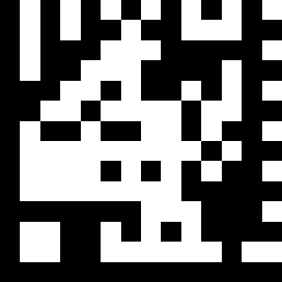 | Led/Beep after transmission. Use this bar code to indicate a "good read" after a bar code has been successfully decoded. | ~ZBX001230.
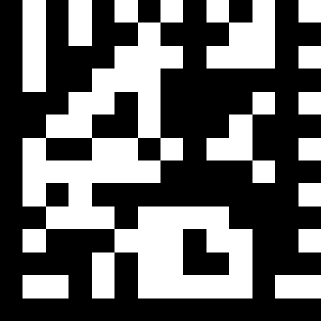 | Led/Beep before transmission, Use this bar code to indicate a good read" after successfully transmitting the bar code data to the host. | ~ZBX001231.
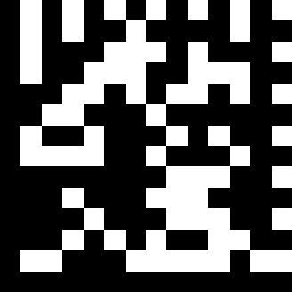 | Power –up tone enable | ~ZBX001233.
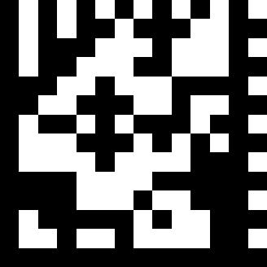 | Power –up tone disable | ~ZBX001234.
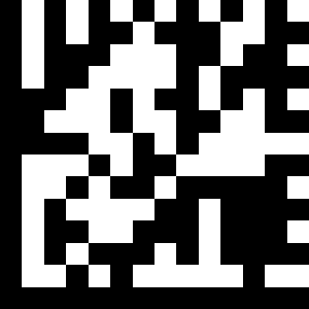 | Return as customer default | ~ZBX000494.
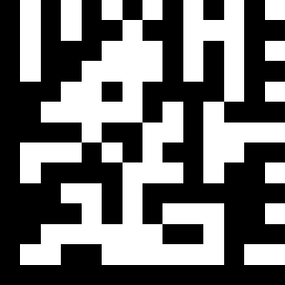 | Save as customer default | ~ZBX000495.
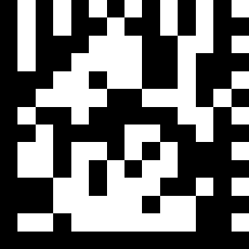 | Return as USB Full Speed | ~ZBX000450.
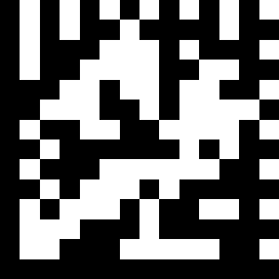 | Return as USB High Speed | ~ZBX000451.
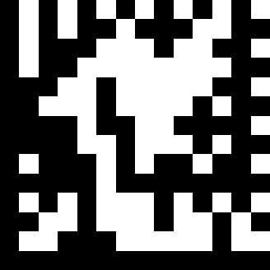 | Return as USB-virtual COM port default (default) | ~ZBX000487.
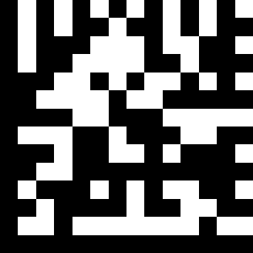 | Return to HID USB default | ~ZBX000497.
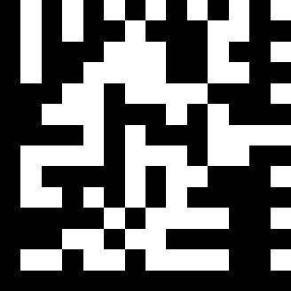 | Return to RS232 default | ~ZBX000499.
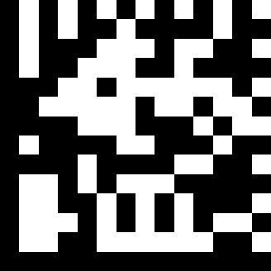 | Return as OPOS port default(USB mode) | ~ZBX000477.
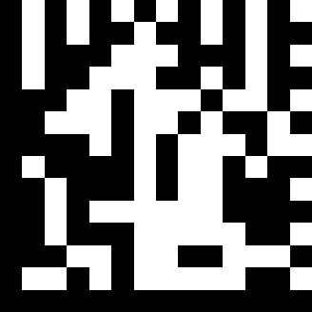 | OPOS RS232 mode | ~ZBX000476.
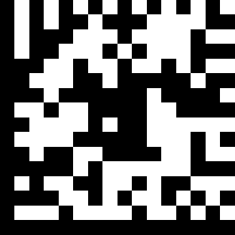 | TEST Mode | ~ZBX0003AA.
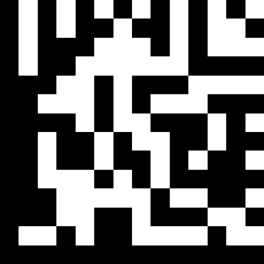 | USB Update mode | ~ZBX000480!
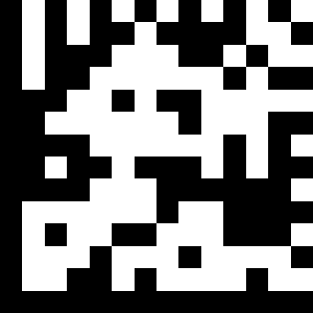 | Uart Update mode | ~ZBX000481!
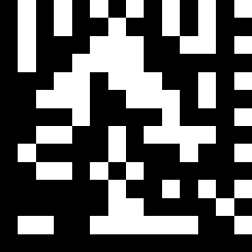 | Image Mode | ~ZBX000483.

AIM light , illumination Light control
 | NO_USE_ILLUM | ~ZBB00820001.
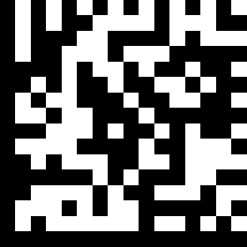 | USE_ILLUM | ~ZBB00820100.
 | NO_USE_AIM | ~ZBB00820002.
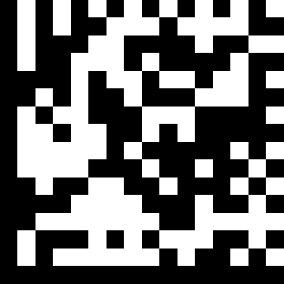 | USE_AIM | ~ZBB00820200.
 | AIM no flash | ~ZBB00820004.
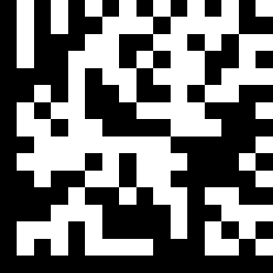 | AIM flash | ~ZBB00820400.

Scan function Setting
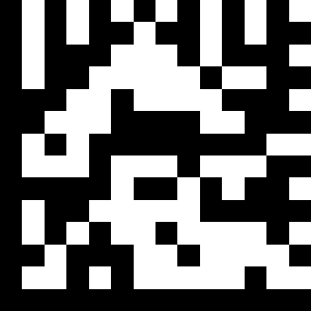 | Trigger mode, | ~ZBX000301.
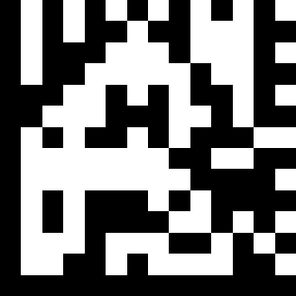 | Auto scan mode, | ~ZBX000302.
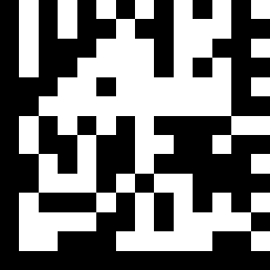 | Presentation mode | ~ZBX000312.
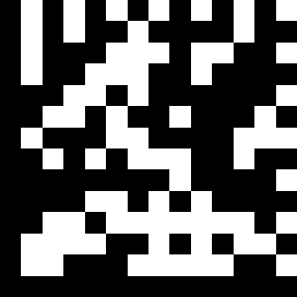 | Same Delay time 50msec | ~ZBX001321.
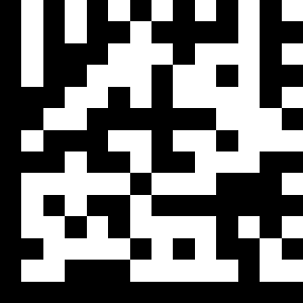 | Same Delay time 100msec | ~ZBX001322.
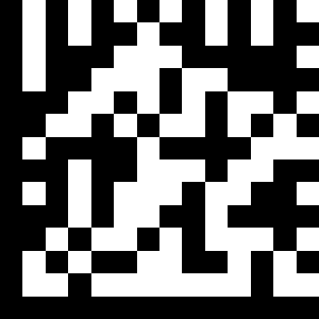 | Same Delay time 200msec | ~ZBX001323.
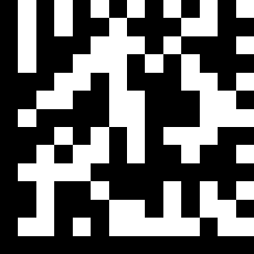 | Same Delay time 300msec | ~ZBX001324.
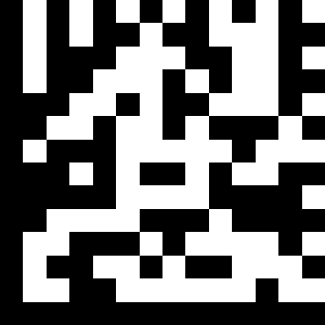 | Same Delay time 400msec | ~ZBX001325.
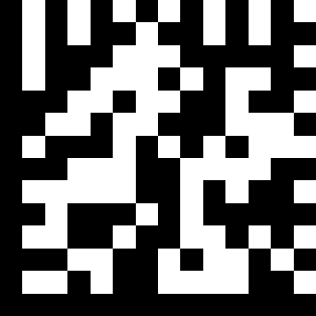 | Same Delay time 500msec | ~ZBX001326.
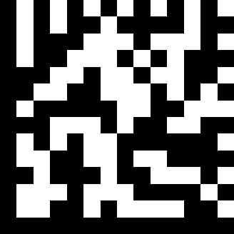 | Same Delay time 600msec | ~ZBX001327.
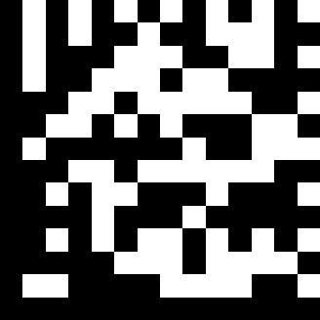 | Same Delay time 700msec | ~ZBX001328.
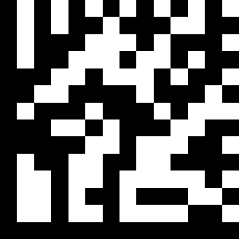 | Same Delay time 800msec | ~ZBX001329.
 | Same Delay time 900msec | ~ZBX00132A.
 | Same Delay time 1000msec | ~ZBX00132B.
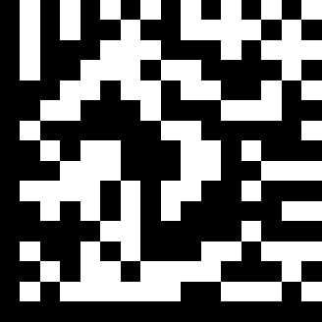 | Same Delay time Infinite | ~ZBX00132C.
RS-232C Interface setting
 | Baud Rate 2400 | ~ZBX000A00.
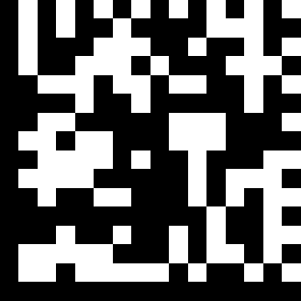 | Baud Rate 4800 | ~ZBX000A01.
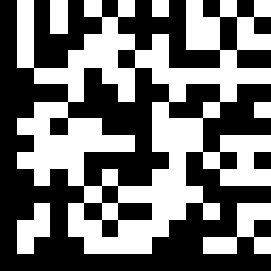 | Baud Rate 9600 | ~ZBX000A02.
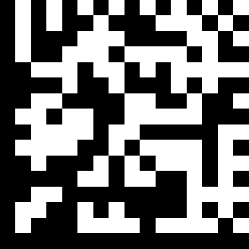 | Baud Rate 19200 | ~ZBX000A03.
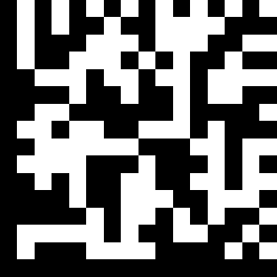 | Baud Rate 38400 | ~ZBX000A04.
 | Baud Rate 57600 | ~ZBX000A05.
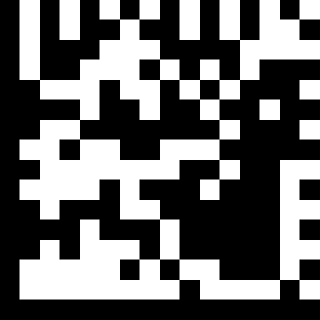 | Baud Rate 115200 | ~ZBX000A06.
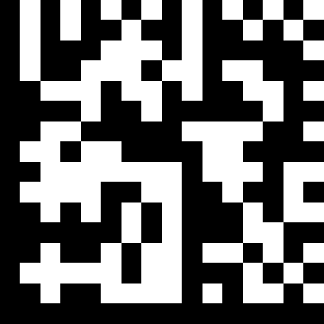 | None handshaking | ~ZBX000A51.
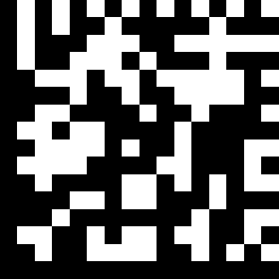 | ACK/NAK | ~ZBX000A52.
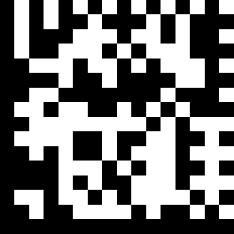 | Xon/Xoff | ~ZBX000A53.
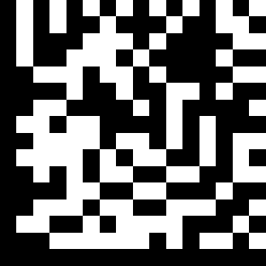 | RTS/CTS | ~ZBX000A54.
 | Even parity | ~ZBX000A31.
 | Odd parity | ~ZBX000A32.
 | None parity | ~ZBX000A35.
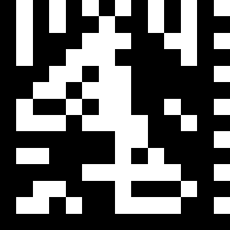 | Enable BEEPER ON<BEL> CHARACTER | ~ZBX001237.
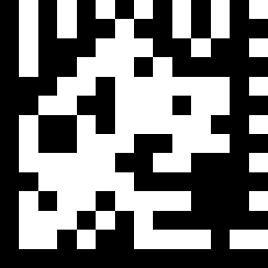 | Ignore BEEP ON <BEL> CHARACTER | ~ZBX001238.
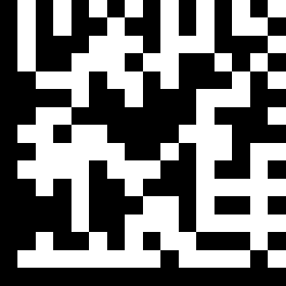 | ACK/NAK response time 300ms | ~ZBX000A71.
 | ACK/NAK response time 2s | ~ZBX000A72.
 | ACK/NAK response time 500ms | ~ZBX000A73.
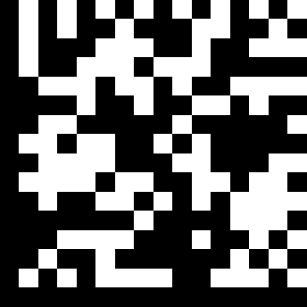 | ACK/NAK response time 3s | ~ZBX000A74.
 | ACK/NAK response time 1s | ~ZBX000A75.
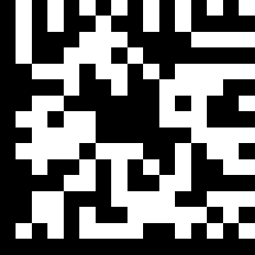 | ACK/NAK response time 5s | ~ZBX000A76.
 | ACK/NAK response time infinity | ~ZBX000A77.
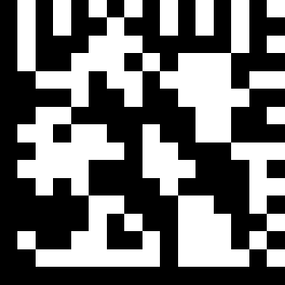 | 1 stop bit | ~ZBX000A41.
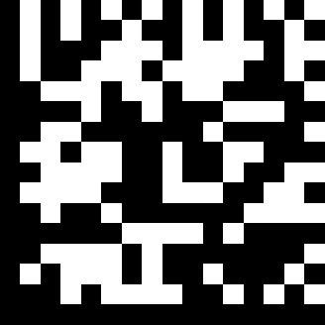 | 2 stop bit | ~ZBX000A42.
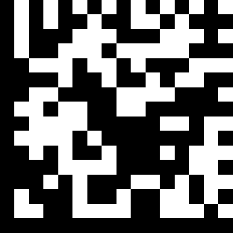 | 7 data bit | ~ZBX000A21.
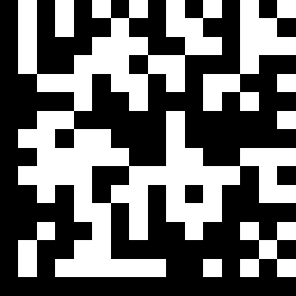 | 8 data bit | ~ZBX000A22.
Terminator

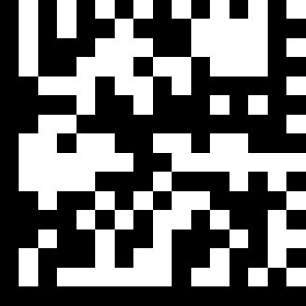 | Message terminator—none | ~ZBX000C01.
 | message terminator—CR/LF | ~ZBX000C02.
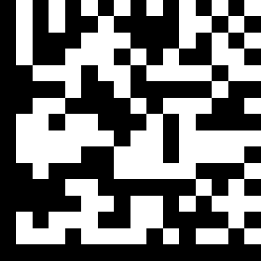 | message terminator—CR | ~ZBX000C03.
 | message terminator—LF | ~ZBX000C04.
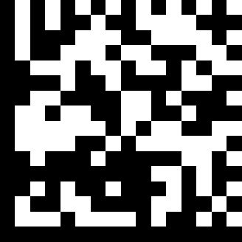 | message terminator—H tab | ~ZBX000C05.
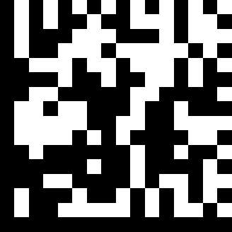 | message terminator—STX/ETX | ~ZBX000C06.
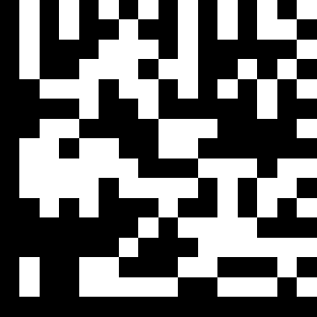 | message terminator—EOT | ~ZBX000C07.
Keyboard wedge and HID Keyboard wedge Setting
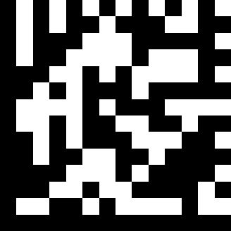 | Enable Alt mode. | ~ZBX001400.
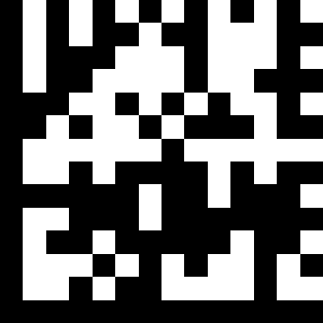 | Keyboard language support---USA | ~ZBX001401.
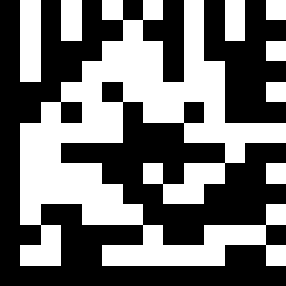 | Keyboard language support---UK send scan code | ~ZBX001402.
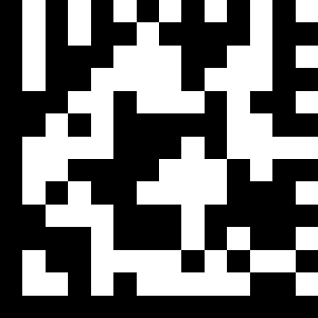 | Keyboard language support---GERMANY | ~ZBX001403.
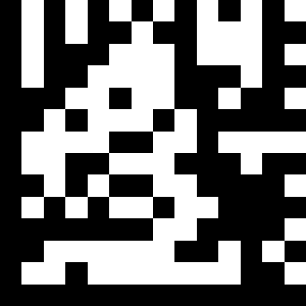 | Keyboard language support---FRENCH send scan code | ~ZBX001404.
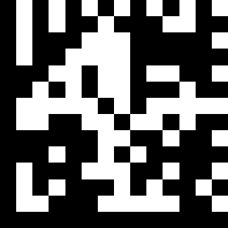 | Keyboard language support---SPANISH send scan code | ~ZBX001405.
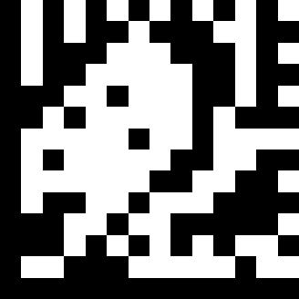 | Keyboard language support---ITALIAN send scan code | ~ZBX001406.
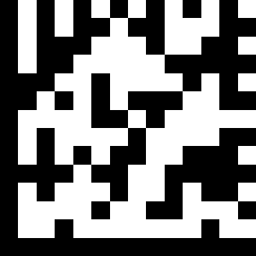 | Keyboard language support--- Switzerland | ~ZBX001407.
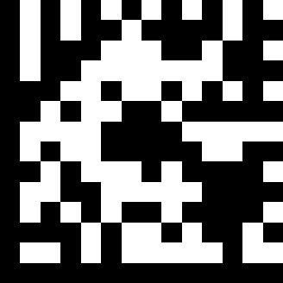 | Keyboard language support---Sweden send scan code | ~ZBX001408.
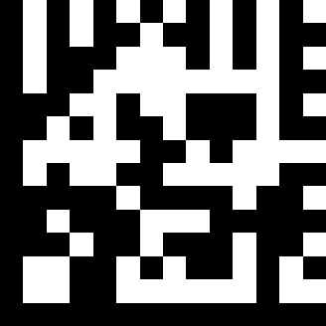 | Keyboard language support---Belgium send scan code | ~ZBX001409.
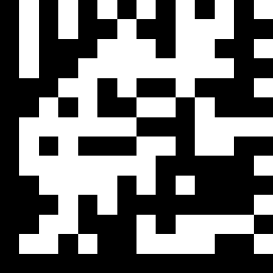 | Keyboard language support---Portugal send scan code | ~ZBX001410.
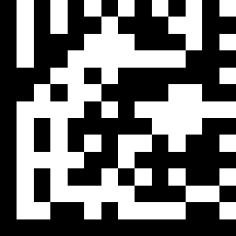 | Keyboard language support---Turkish send scan code | ~ZBX001411.
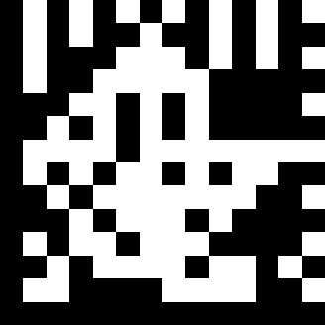 | Keyboard language support---Hungary | ~ZBX001412.
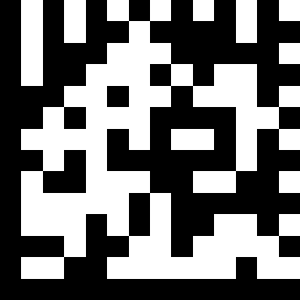 | Keyboard language support---Japanese | ~ZBX001415.
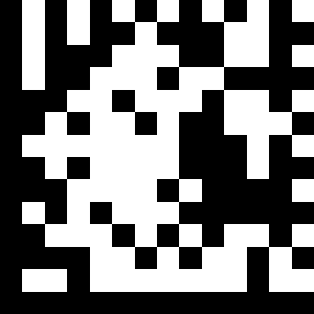 | Keyboard language support---iMac-French | ~ZBX001417.
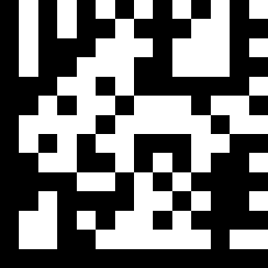 | Capital lock on | ~ZBX001440.
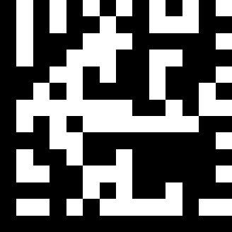 | Capital lock off | ~ZBX001441.
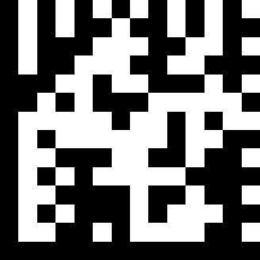 | Function key emulation enable | ~ZBX001442.
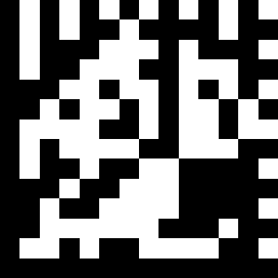 | Function key emulation disable | ~ZBX001443.
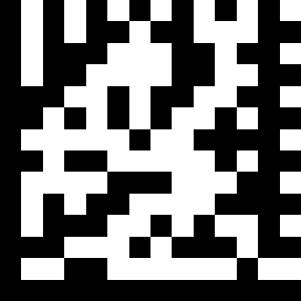 | Send number as normal data | ~ZBX001446.
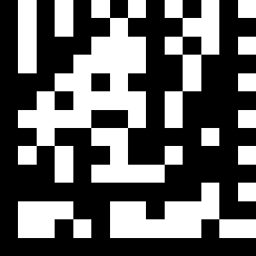 | Send number as keypad data | ~ZBX001447.

CODABAR
 | Codabar enable | ~ZBB000A0001.
 | CODABAR disable | ~ZBB000A0100.
 | Codabar data redundant check=off | ~ZBB00853000.
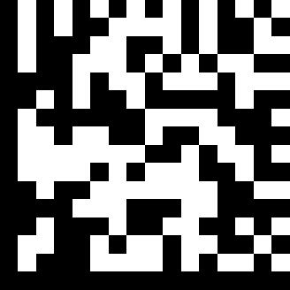 | Codabar data redundant check=1 | ~ZBB00853010.
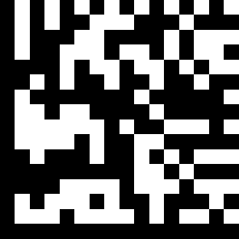 | Codabar data redundant check=2 | ~ZBB00853020.
 | Codabar data redundant check=3 | ~ZBB00853030.
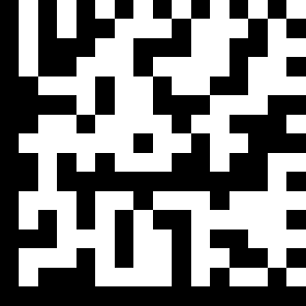 | Codabar start/stop character transmission-----none | ~ZBB000A0200.
 | Codabar start/stop character transmission-----A,B,C,D | ~ZBB000AF062.
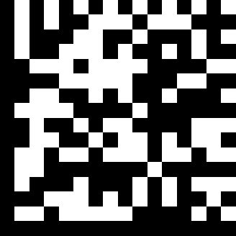 | Codabar start/stop character transmission-----DC1~DC4 | ~ZBB000AF072.
 | Codabar start/stop character transmission-----a/t,b/n,c/*,d/e | ~ZBB000AF082.
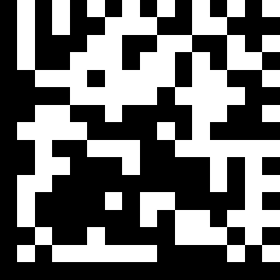 | Codabar start/stop character transmission -a,b,c,d | ~ZBB000AF092.
 | Codabar maximum length setting | ~ZBX000B08!
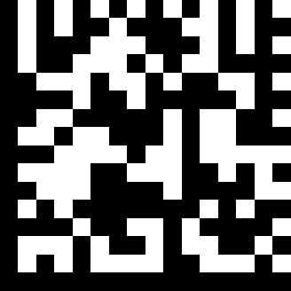 | Codabar minimum length setting | ~ZBX000B09!
 | No check character | ~ZBB000A0800.
 | Validate modulo 16,but don’t transmit | ~ZBB000A0408.
 | Validate modulo 16,but transmit | ~ZBB000A000C.
Code39
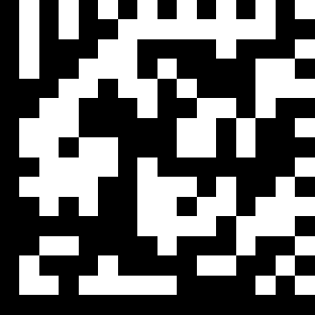 | Code 39 enable | ~ZBB00070001.
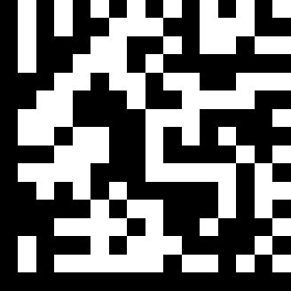 | Code 39 disable | ~ZBB00070100.
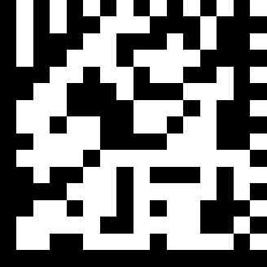 | Code 32 enable | ~ZBB00070021.
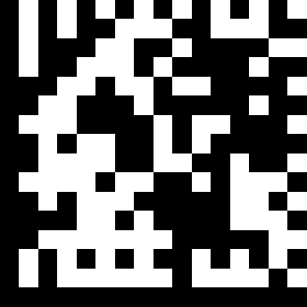 | Code 32 disable | ~ZBB00072000.
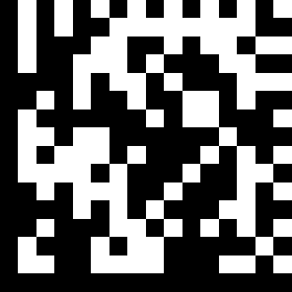 | Code 39 data redundant check=off | ~ZBB00850300.
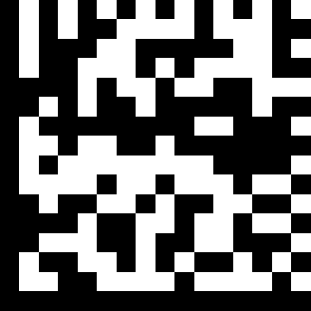 | Code 39 data redundant check=1 | ~ZBB00850301.
 | Code 39 data redundant check=2 | ~ZBB00850302.
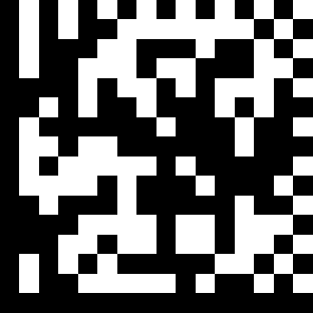 | Code 39 data redundant check=3 | ~ZBB00850303.
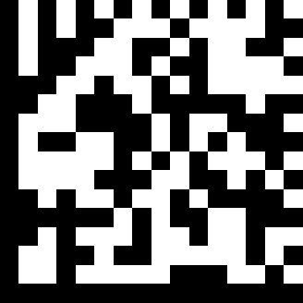 | Standard code 39 | ~ZBB00071001.
 | FULL ASCII code 39 | ~ZBB00070011.
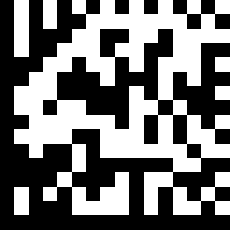 | Code 39 start/stop character transmission | ~ZBB00070002.
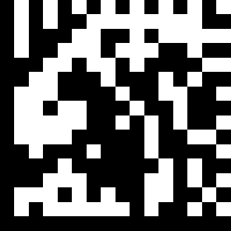 | Code 39 start/stop character without transmission | ~ZBB00070200.
 | Code 39 check digit calculate and transmit | ~ZBB0007000C.
 | Code 39 check digit calculate but without transmit | ~ZBB00070804.
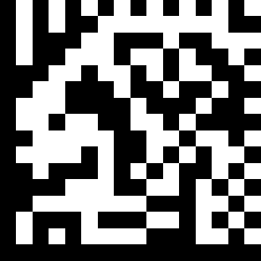 | No check character | ~ZBB00070400.
 | Code 39 maximum length setting | ~ZBX000B04!
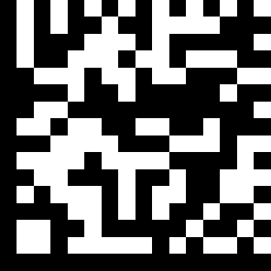 | Code 39 minimum length setting | ~ZBX000B05!
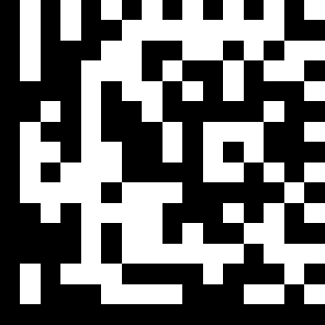 | Code39 Data Redundant check = off | ~ZBB00840300.
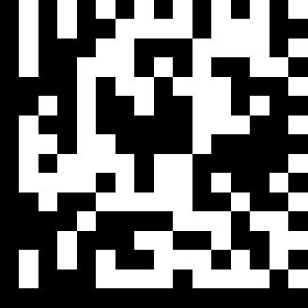 | Code39 Data Redundant check = 1 | ~ZBB00840301.
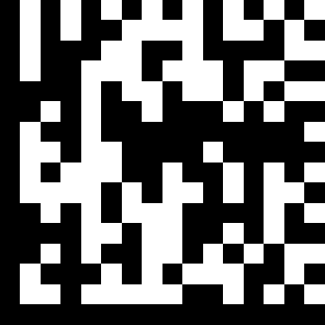 | Code39 Data Redundant check = 2 | ~ZBB00840302.
 | Code39 Data Redundant check = 3 | ~ZBB00840303.
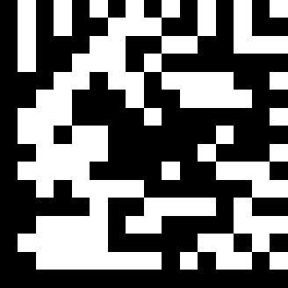 | Code 32 (Italian pharmacy)transmit “A” character | ~ZBB00070040.
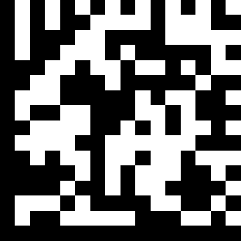 | Code 32 (Italian pharmacy)without transmit ”A” character | ~ZBB00074000.
Code 93
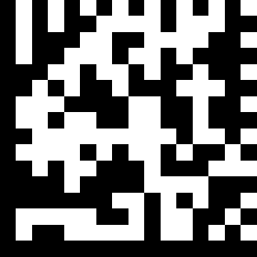 | Code 93 enable | ~ZBB00150001.
 | Code 93 disable | ~ZBB00150100.
 | Code 93 data redundant check=off | ~ZBB00860C00.
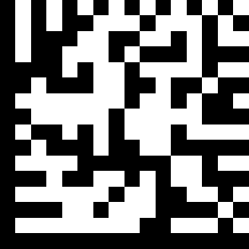 | Code 93 data redundant check=1 | ~ZBB00860C04.
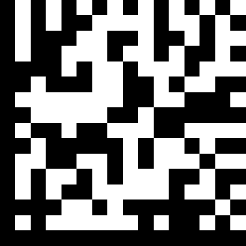 | Code 93 data redundant check=2 | ~ZBB00860C08.
 | Code 93 data redundant check=3 | ~ZBB00860C0C.
 | Code 93 maximum length setting | ~ZBX000B06!
 | Code 93 minimum length setting | ~ZBX000B07!
Code 128
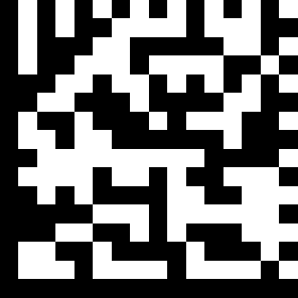 | Code 128 enable | ~ZBB00120001.
 | Code 128 disable | ~ZBB00120100.
 | EAN –128 enable | ~ZBB00120003.
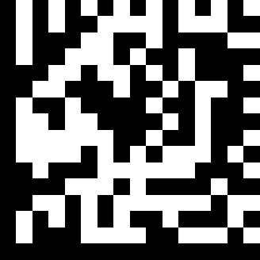 | EAN-128 disable | ~ZBB00120200.
 | Code 128 data redundant check=off | ~ZBB00860300.
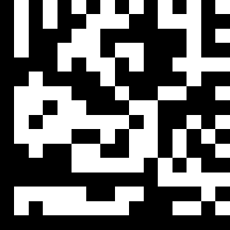 | Code 128 data redundant check=1 | ~ZBB00860301.
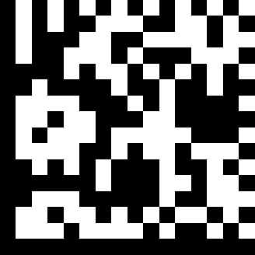 | Code 128 data redundant check=2 | ~ZBB00860302.
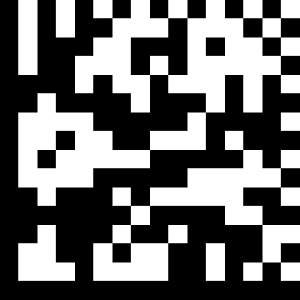 | Code 128 data redundant check=3 | ~ZBB00860303.
 | Code 128 maximum length setting | ~ZBX000B02!
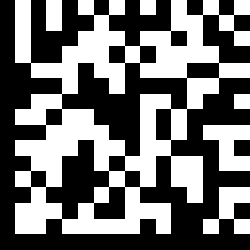 | Code 128 minimum length setting | ~ZBX000B03!
Chinese post code(SLZ)
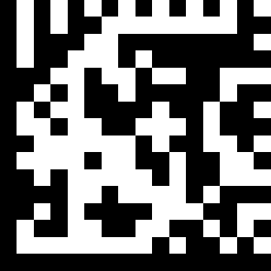 | Chinese post code enable | ~ZBB00180001.
 | Chinese post code disable | ~ZBB00180100.
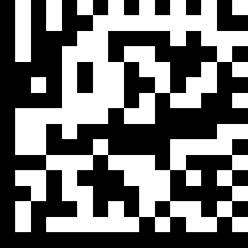 | Chinese post code data redundant check=off | ~ZBB0084C000.
 | Chinese post code data redundant check=1 | ~ZBB0084C040.
 | Chinese post code data redundant check=2 | ~ZBB0084C080.
3  | Chinese post code data redundant check=3 | ~ZBB0084C0C0.
 | Chinese post code check digit calculate and transmit | ~ZBB001800C0.
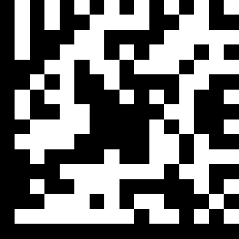 | Chinese post code check digit calculate but without transmit | ~ZBB00184080.
MSI/PLESSY
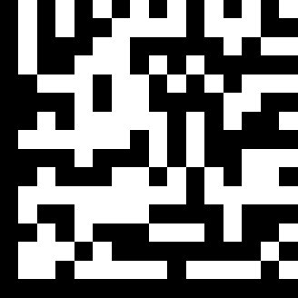 | MSI enable | ~ZBB001B0001.
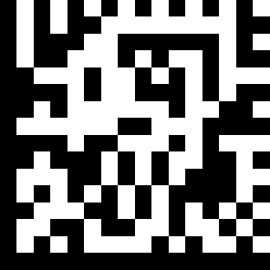 | MSI disable | ~ZBB001B0100.
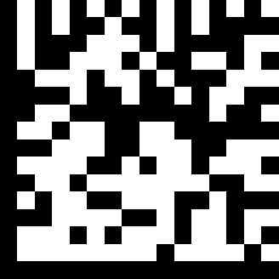 | MSI/PLESSY maximum length setting | ~ZBX000B12!
 | MSI/PLESSY minimum length setting | ~ZBX000B13!
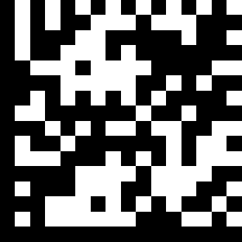 | MSI/Plessy double check digit calculate but not transmit | ~ZBB001BFF83.
 | MSI/Plessy double check digit without calculate and transmit | ~ZBB001BFF01.
 | MSI/Plessy double check digit calculate but only first digit transmit | ~ZBB001BFFCB.
 | MSI/Plessy double check digit calculate and both transmit | ~ZBB001BFFC3.
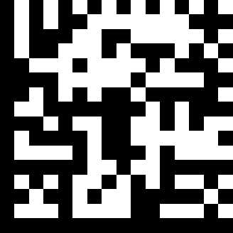 | MSI/Plessy single check digit calculate but without transmit | ~ZBB001BFF85.
 | MSI/Plessy single check digit calculate and transmit | ~ZBB001BFFC5.
CODE 11
 | CODE 11 enable | ~ZBB002C0001.
 | CODE 11 disable | ~ZBB002C0100.
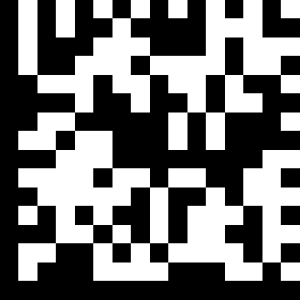 | CODE 11 maximum length setting  Default length 6 ~32 character | ~ZBX000B00!
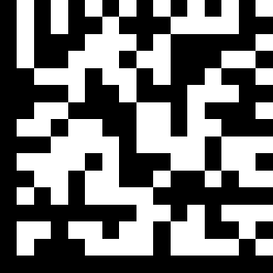 | CODE 11 minimum length setting | ~ZBX000B01!
 | Code 11 check digit transmitted | ~ZBB002C0002.
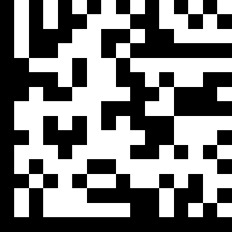 | Code 11 check digit not transmitted | ~ZBB002C0200.
ITF 2 of 5
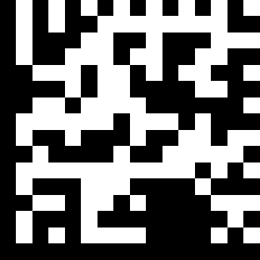 | ITF 2 of 5 enable | ~ZBB000D0001.
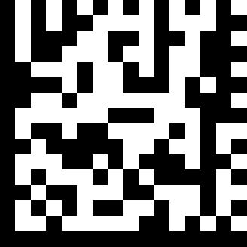 | ITF 2 of 5 disable | ~ZBB000D0100.
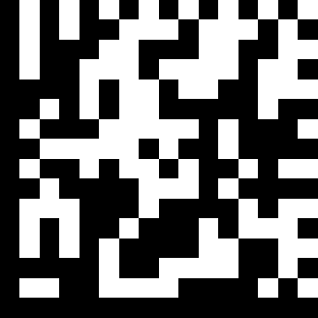 | ITF 25 data redundant check=off | ~ZBB00850C00.
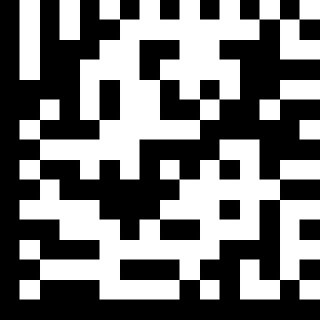 | ITF25 data redundant check=1 | ~ZBB00850C04.
 | ITF25 data redundant check=2 | ~ZBB00850C08.
 | ITF 25 data redundant check=3 | ~ZBB00850C0C.
 | ITF 2 of 5 code maximum length setting | ~ZBX000B10!
 | ITF 2 of 5 code minimum length setting | ~ZBX000B11!
 | ITF 2 of 5 no check character | ~ZBB000D0400.
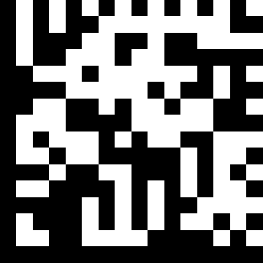 | ITF 2 of 5 check digit calculate and transmit | ~ZBB000D000C.
 | ITF 2 of 5 check digit calculate but without transmit | ~ZBB000D0804.
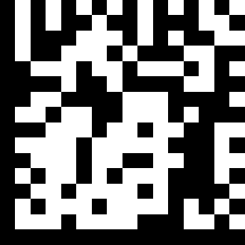 | ITF 2 of 5 one Fixed length setting | ~ZBX000B22!
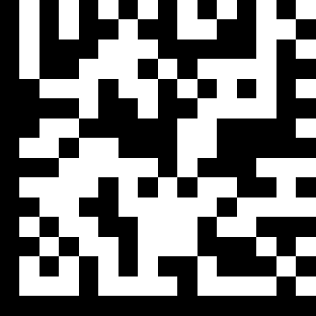 | ITF 2 of 5 two Fixed length setting | ~ZBX000B23!
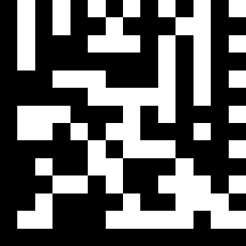 | ITF 2 of 5 length variable | ~ZBX555501.

Telepen
 | Telepen Enable | ~ZBB00320001.
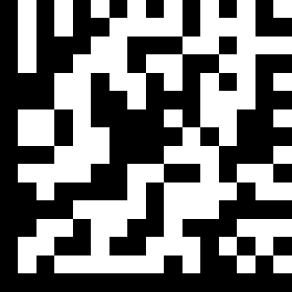 | Telepen Disable | ~ZBB00320100.

Pharmacode
 | Pharmacode Enable | ~ZBB003D0001.
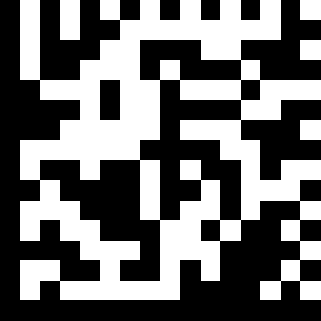 | Pharmacode Disable | ~ZBB003D0100.

UPC/EAN/JAN
 | EAN convert to ISSN/ISBN enable | ~ZBB00060004.
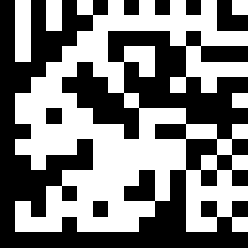 | EAN convert to ISSN.ISBN disable | ~ZBB00060400.
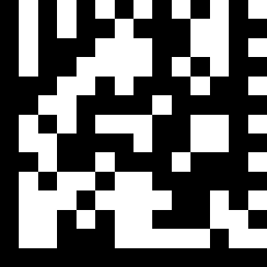 | UPC/EAN/JAN enable | ~ZBX001100.
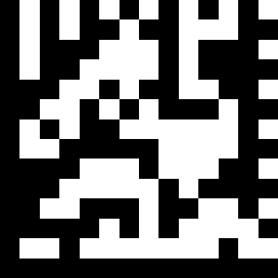 | UPC/EAN/JAN disable | ~ZBX001101.
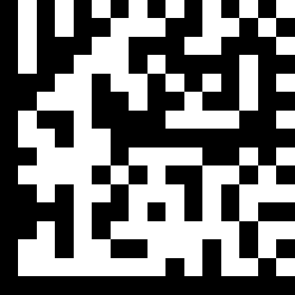 | EAN-8 OR EAN-13 ENABLE | ~ZBB00040003.
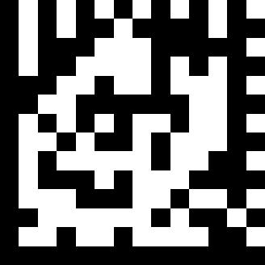 | UPC-A AND EAN-13 ENABLE | ~ZBX001103.
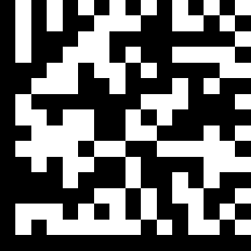 | UPC-A AND UPC-E ENABLE | ~ZBB00050003.
 | UPC-A ENABEL | ~ZBB00050001.
 | UPC-E ENABLE | ~ZBB00050002.
 | EAN-13 ENABLE | ~ZBB00040001.
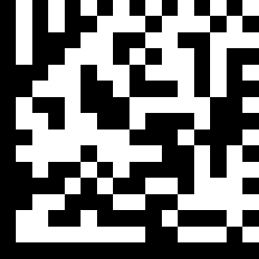 | EAN-8 ENABEL | ~ZBB00040002.
 | UPC/EAN ADDon off | ~ZBB00040C00.
 | Addon 5 only | ~ZBB00040C08.
 | Addon 2 only | ~ZBB00040C04.
 | Addon 2 or 5 | ~ZBB0004000C.
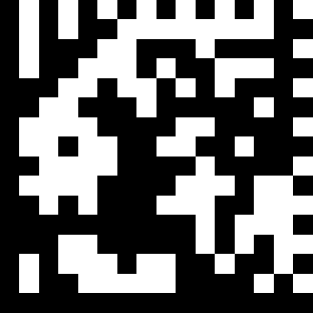 | Force UPC-E to UPC-A format enable | ~ZBB00060001.
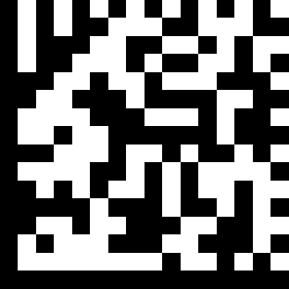 | Force UPC-E to UPC-A format disable | ~ZBB00060100.
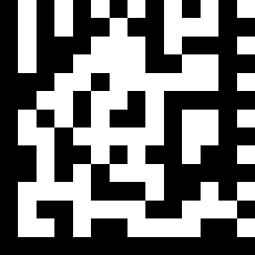 | Force UPC-A to EAN-13 format enable | ~ZBX001104.
 | Force UPC-A to EAN-13 format disable | ~ZBB00060200.
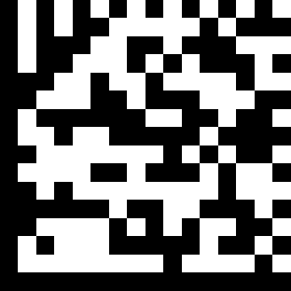 | Transmit UPC-A check digit enable | ~ZBB00050020.
 | Transmit UPC-A check digit disable | ~ZBB00052000.
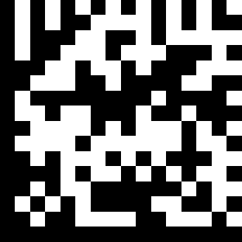 | Transmit UPC-E leading character enable | ~ZBB00050040.
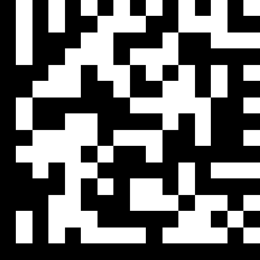 | Transmit UPC-E leading character disable | ~ZBB00054000.
 | Transmit UPC-E check digit enable | ~ZBB00050080.
 | Transmit UPC-E check digit disable | ~ZBB00058000.
 | Transmit EAN-8 check digit enable | ~ZBB00040080.
 | Transmit EAN-8 check digit disable | ~ZBB00048000.
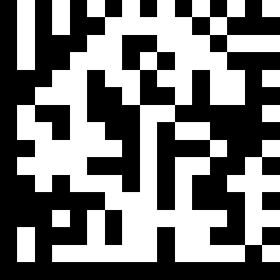 | Transmit EAN-13 check digit enable | ~ZBB00040020.
 | Transmit EAN-13 check digit disable | ~ZBB00042000.
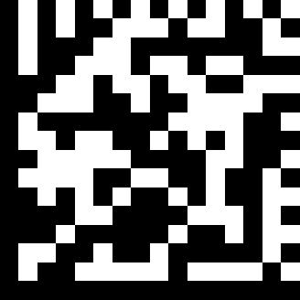 | Transmit UPC-A leading character enable | ~ZBB00050010.
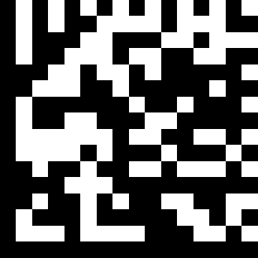 | Transmit UPC-A leading character disable | ~ZBB00051000.
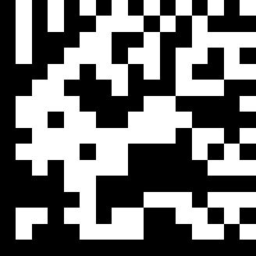 | Addon format with separator | ~ZBB00060020.
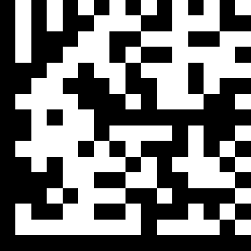 | Addon format without separator | ~ZBB00062000.
 | EAN/UPC +addon (none mandatory) | ~ZBX000E32.
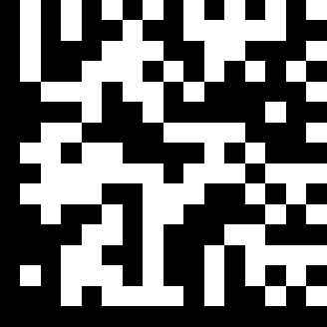 | EAN/UPC +addon (mandatory) | ~ZBX000E33.
 | EAN-8 to EAN-13 format enable | ~ZBB00350002.
 | force EAN-8 to EAN-13 format disable | ~ZBB00350200.
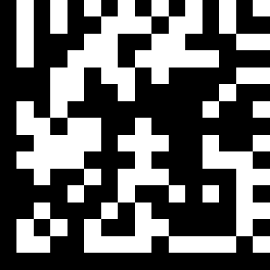 | EAN-13 first “0” can transmitted | ~ZBB00350008.
 | EAN-13 first:”0” can’t transmitted | ~ZBB00350800.
 | EAN-13 with first 0 ID code same as “UPC-A” | ~ZBB00350400.
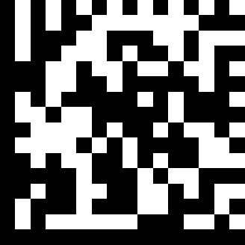 | EAN-13 with first 0 ID code same as “EAN-13” | ~ZBB00350004.
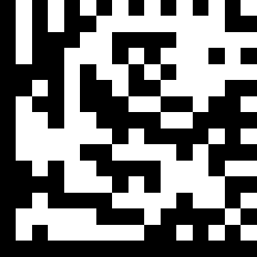 | UPC-A data redundant check=off | ~ZBB00843000.
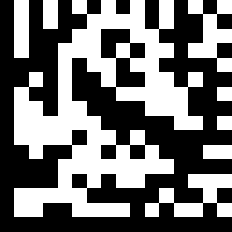 | UPC-A data redundant check=1 | ~ZBB00843010.
 | UPC-A data redundant check=2 | ~ZBB00843020.
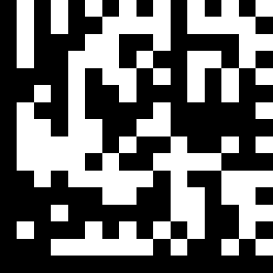 | UPC-A data redundant check=3 | ~ZBB00843030.
 | UPC-E data redundant check=off | ~ZBB0084C000.
 | UPC-E data redundant check=1 | ~ZBB0084C040.
 | UPC-E data redundant check=2 | ~ZBB0084C080.
 | UPC-E data redundant check=3 | ~ZBB0084C0C0.
 | EAN-13 data redundant check=off | ~ZBB00840300.
 | EAN-13 data redundant check=1 | ~ZBB00840301.
 | EAN-13 data redundant check=2 | ~ZBB00840302.
 | EAN-13 data redundant check=3 | ~ZBB00840303.
 | EAN-8 data redundant check=off | ~ZBB00840C00.
 | EAN-8 data redundant check=1 | ~ZBB00840C04.
 | EAN-8 data redundant check=2 | ~ZBB00840C08.
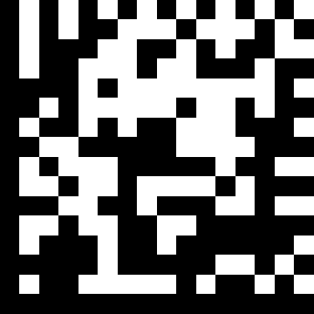 | EAN-8 data redundant check=3 | ~ZBB00840C0C.

Standard 2 of 5
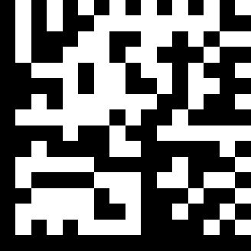 | STD 2 of 5 code enable | ~ZBB001F0001.
 | STD 2 of 5 code disable | ~ZBB001F0100.
 | Standard 2 of 5 check digit calculate and transmit | ~ZBB001F00C0.
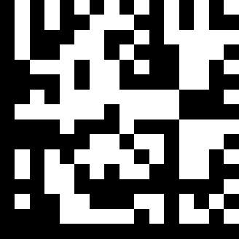 | Standard 2 of 5 check digit calculate without transmit | ~ZBB001F4080.
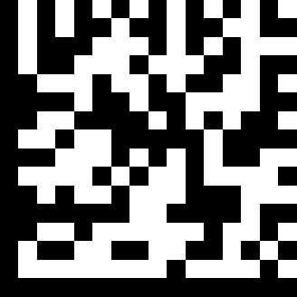 | STD 2 of 5 code maximum length setting Default:6~32 | ~ZBX000B16.
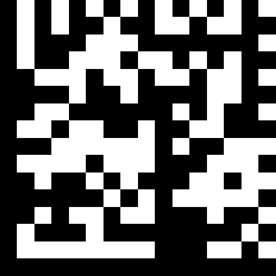 | STD 2 of 5 code minimum length setting | ~ZBX000B17.

Industrial 2 of 5
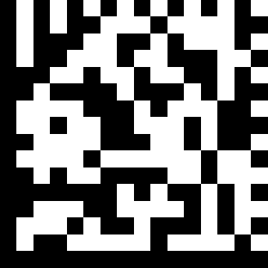 | Industrial 2 of 5 Enable | ~ZBB00220001.
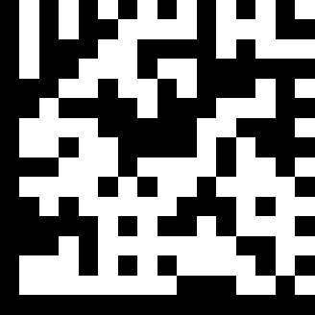 | Industrial 2 of 5 Disable | ~ZBB00220100.
 | Industrial 2 of 5 check digit calculate and transmit | ~ZBB002200C0.
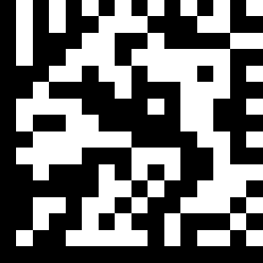 | Industrial 2 of 5 check digit calculate without transmit | ~ZBB00224080.
 | Industrial 2 of 5 code maximum length setting Default:6~32 | ~ZBX000B20.
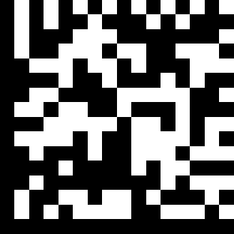 | Industrial 2 of 5 code minimum length setting | ~ZBX000B21.
Matrix 2 of 5
 | Matrix 2/5 code enable | ~ZBB002F0021.
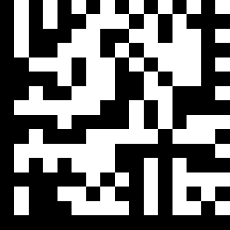 | Matrix 2/5 code disable | ~ZBB002F2100.
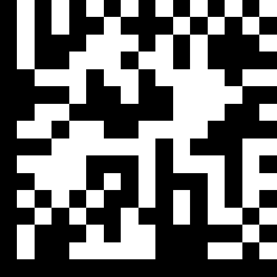 | Matrix 2/5 code minimum length setting | ~ZBX000B19!
 | Matrix 2 of 5 check digit calculate and transmit | ~ZBB002A6060.
 | Matrix 2 of 5 check digit calculate without transmit | ~ZBB002A6020.
GS1 Databar
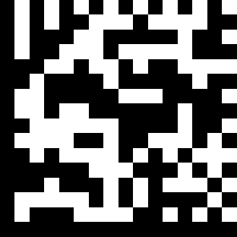 | GS1 Databar enable | ~ZBB00250001.
 | GS1 Databar disable | ~ZBB00250100.
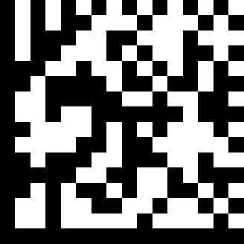 | GS1 Databar LIMITED enable | ~ZBB00250002.
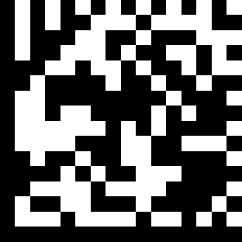 | GS1 Databar LIMITED disable | ~ZBB00250200.
 | GS1 Databar EXPANDED enable | ~ZBB00250004.
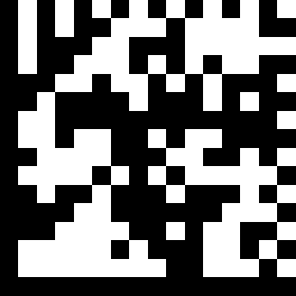 | GS1 Databar EXPANDED disable | ~ZBB00250400.
 | GS1 Data Redundant check = off | ~ZBB00880300.
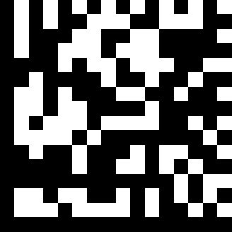 | GS1 Data Redundant check = 1 | ~ZBB00880301.
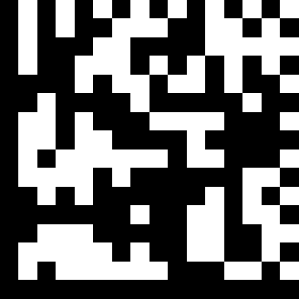 | GS1 Data Redundant check = 2 | ~ZBB00880302.
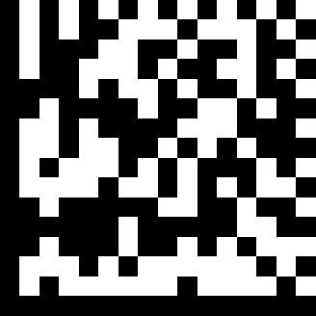 | GS1 Data Redundant check = 3 | ~ZBB00880303.
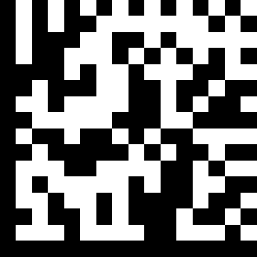 | GS1 Limited Data Redundant check = off | ~ZBB00880C00.
 | GS1 Limited Data Redundant check = 1 | ~ZBB00880C04.
 | GS1 Limited Data Redundant check = 2 | ~ZBB00880C08.
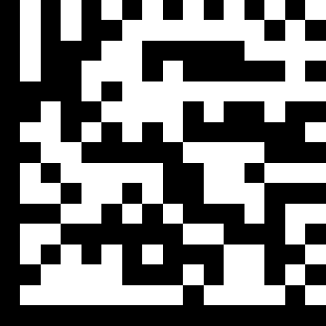 | GS1 Limited Data Redundant check = 3 | ~ZBB00880C0C.
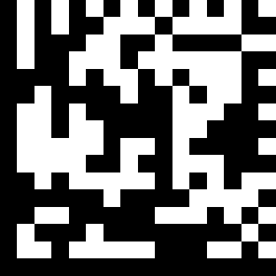 | GS1 Expanded Data Redundant check = off | ~ZBB00883000.
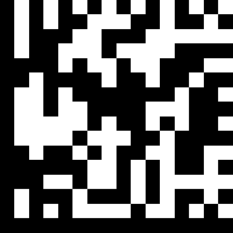 | GS1 Expanded Data Redundant check = 1 | ~ZBB00883010.
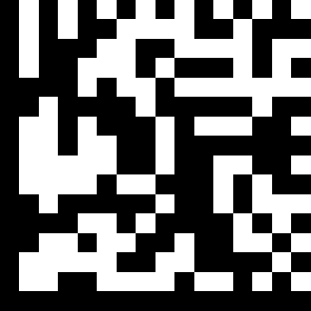 | GS1 Expanded Data Redundant check = 2 | ~ZBB00883020.
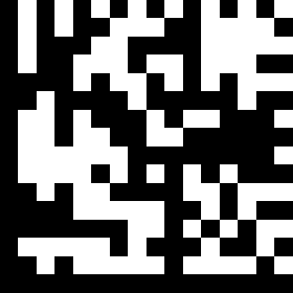 | GS1 Expanded Data Redundant check = 3 | ~ZBB00883030.

QR Code
 | QR Code enable | ~ZBB004A0001.
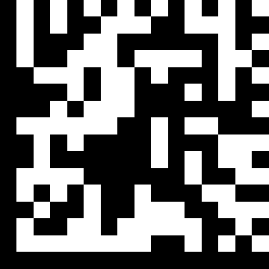 | QR Code disable | ~ZBB004A0100.
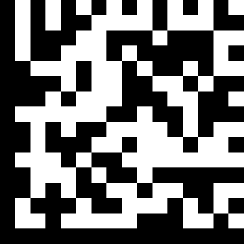 | Micro QR Code enable | ~ZBB004A0002.
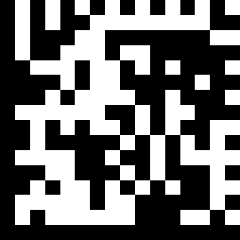 | QR Mode1 1 Code enable | ~ZBB004A0004.
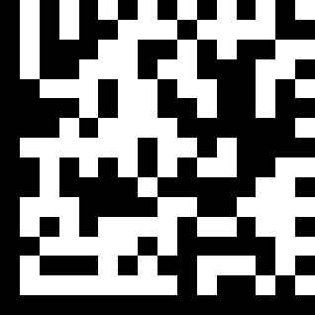 | QR Mode1 1 Code disable | ~ZBB004A0400.
 | Micro QR Code disable | ~ZBB004A0200.
 | QR Code Mirror enable | ~ZBB004A0008.
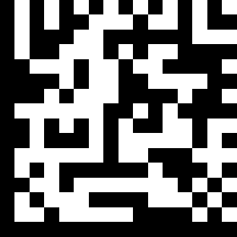 | QR Code Mirror disable | ~ZBB004A0800.
 | QR/MQR polarity setting = Dark on Light | ~ZBB004A3010.
 | QR/MQR polarity setting = Light on Dark | ~ZBB004A3020.
 | QR/MQR polarity setting = either | ~ZBB004A3000.

DataMatrix
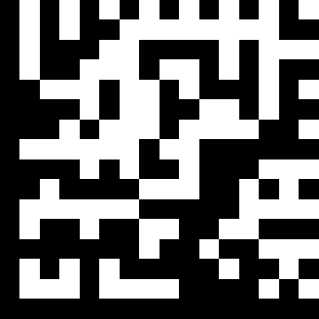 | DataMatrix enable | ~ZBB004B0001.
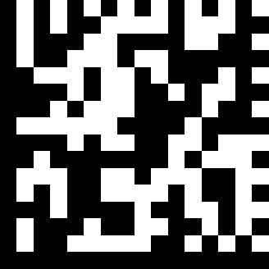 | DataMatrix disable | ~ZBB004B0100.
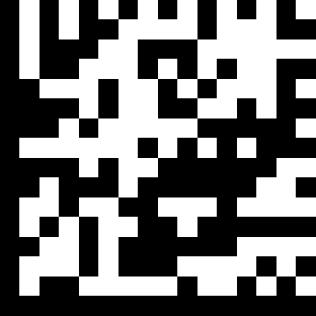 | DataMatrix Mirror enable | ~ZBB004B0008.
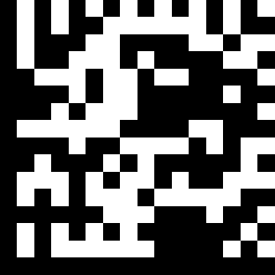 | DataMatrix Mirror disable | ~ZBB004B0800.
 | DataMatrix polarity setting = Dark on Light | ~ZBB004B3010.
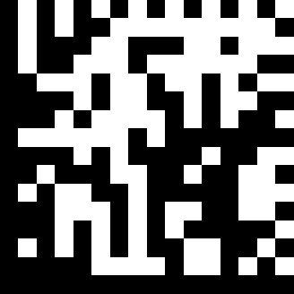 | DataMatrix polarity setting = Light on Dark | ~ZBB004B3020.
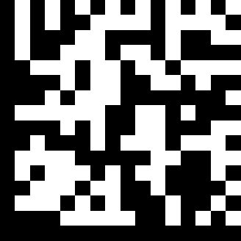 | DataMatrix polarity setting = either | ~ZBB004B3000.

PDF417
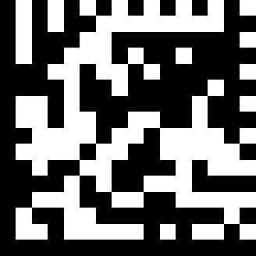 | PDF417 enable | ~ZBB00480001.
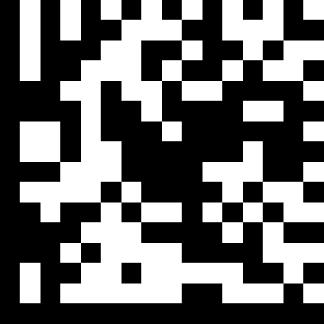 | PDF417 disable | ~ZBB00480100.
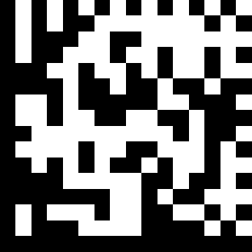 | Micro PDF417 enable | ~ZBB00480002.
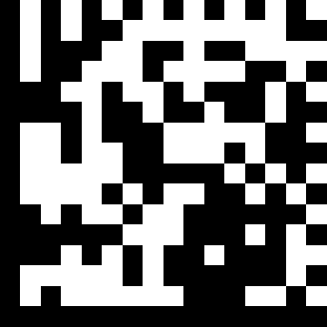 | Micro PDF417e disable | ~ZBB00480200.
 | PDF417 Data Redundant check = off | ~ZBB0087C000.
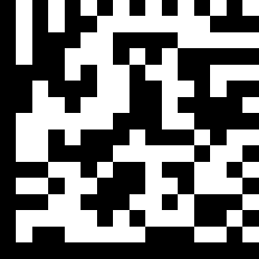 | PDF417 Data Redundant check = 1 | ~ZBB0087C040.
 | PDF417 Data Redundant check = 2 | ~ZBB0087C080.
 | PDF417 Data Redundant check = 3 | ~ZBB0087C0C0.

Aztec
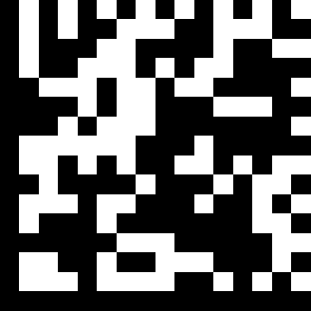 | Aztec enable | ~ZBB004C0001.
 | Aztec disable | ~ZBB004C0100.
 | Aztec Mirror enable | ~ZBB004C0008.
 | Aztec Mirror disable | ~ZBB004C0800.
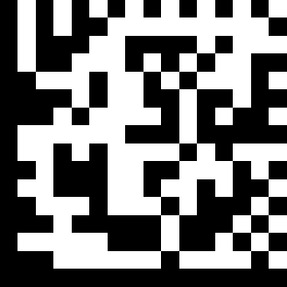 | Aztec polarity setting = Dark on Light | ~ZBB004C3010.
 | Aztec polarity setting = Light on Dark | ~ZBB004C3020.
 | Aztec polarity setting = either | ~ZBB004C3000.
Maxi Code
 | Maxi code enable | ~ZBB004D0001.
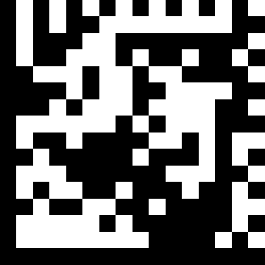 | Maxi code disable | ~ZBB004D0100.
POST code
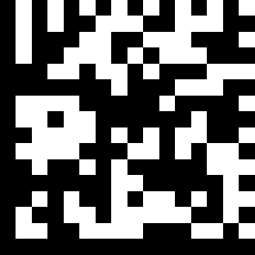 | PostNet Enable | ~ZBB00540001.
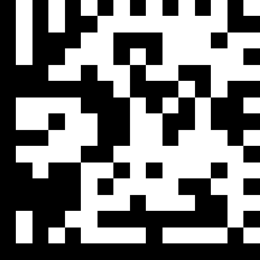 | PostNet Disable | ~ZBB00540100.
 | PLANET Enable | ~ZBB00540002.
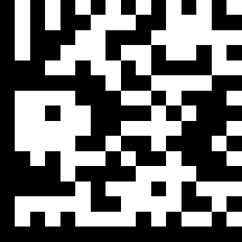 | PLANET Disable | ~ZBB00540200.
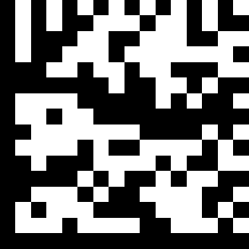 | Australia Post Enable | ~ZBB00540008.
 | Australia Post Disable | ~ZBB00540800.
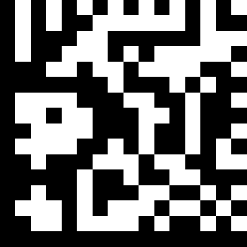 | Royal Post Enable | ~ZBB00540040.
 | Royal Post Disable | ~ZBB00544000.

CODABLOC F
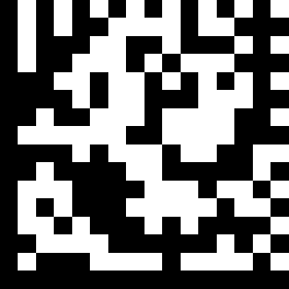 | CODABLOC F Disable | ~ZBB0049FF00.
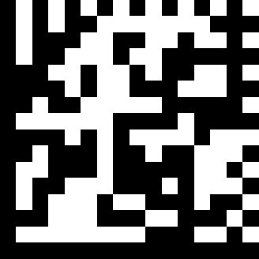 | CODABLOC F CCA Enable | ~ZBB0049FF09.
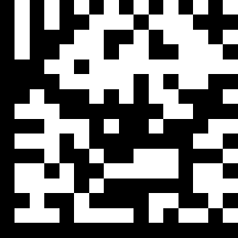 | CODABLOC F CCB Enable | ~ZBB0049FF0A.
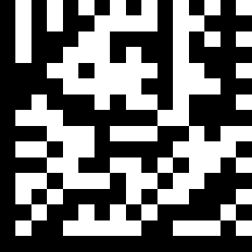 | CODABLOC F CCC Enable | ~ZBB0049FF0C.
 | CODABLOC F ALL Enable | ~ZBB0049FF0F.

Data Editing
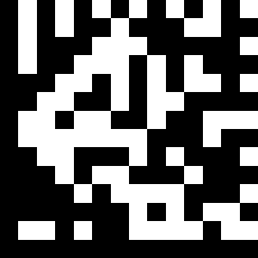 IS00 | Disable identifier code | ~ZBX000800.
IS01 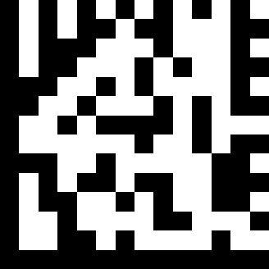 | Enable identifier code table as ZEBEX standard | ~ZBX000801.
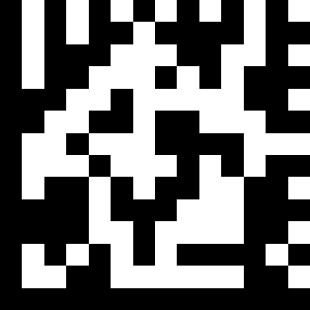 IS03 | Enable identifier code table as AIM standard. Refer to appendix A. | ~ZBX000803.
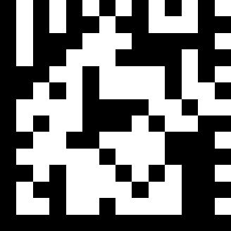 | Add code length as header enable(all barcode) | ~ZBX001444.
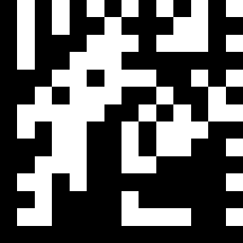 | Add code length as header disable (all barcode) | ~ZBX001445.
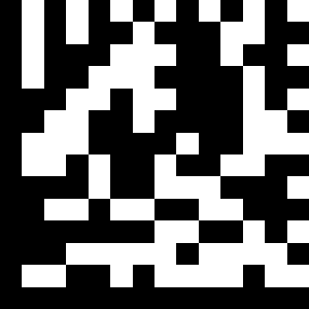 | Header (Preamble) | ~ZBX000701.
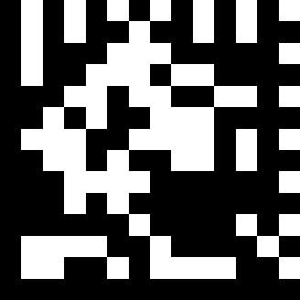 | Inter character delay 0ms | ~ZBX001521.
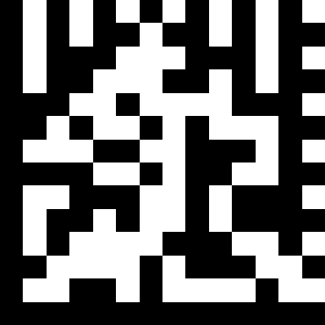 | Inter character delay 2ms | ~ZBX001522.
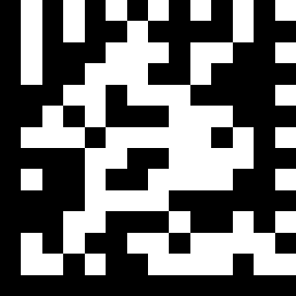 | Inter character delay 5ms | ~ZBX001523.
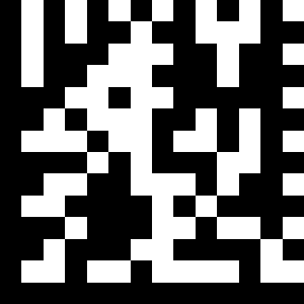 | Inter character delay 10ms | ~ZBX001524.
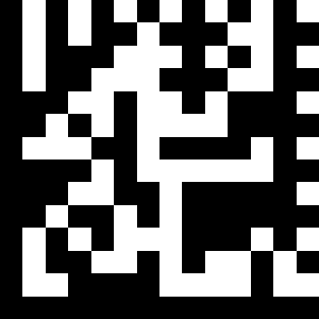 | Inter character delay 20ms | ~ZBX001525.
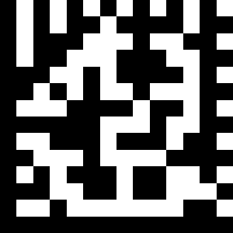 | Inter character delay 50ms | ~ZBX001526.
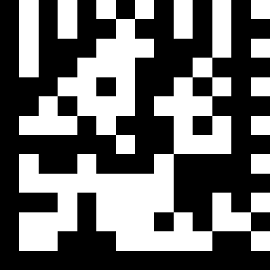 | Inter character delay 90msec | ~ZBX001527.
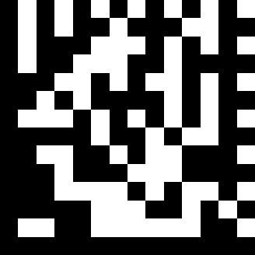 | Inter character delay 100msec | ~ZBX001528.
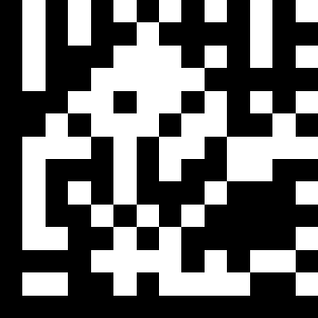 | Inter message delay 0 ms | ~ZBX001511.
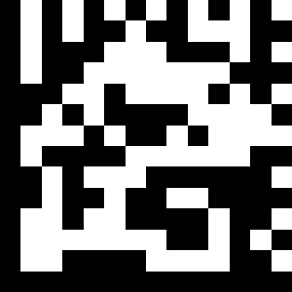 | Inter message delay 100 ms | ~ZBX001512.
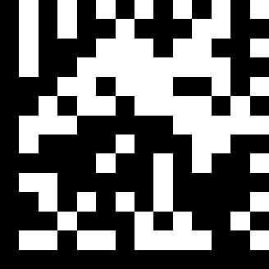 | Inter message delay 500 ms | ~ZBX001513.
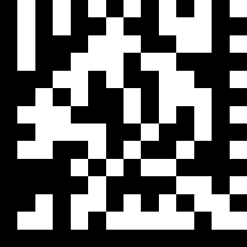 | Inter message delay 1000 ms | ~ZBX001514.

